

Informatica Intelligent Data Management Cloud

Project Report

COURSE DETAILS:

Course Name | Informatica
Course Code | 25ECSE322
Semester | VI
Division | C

TEAM DETAILS:

NAME | ROLL NO | USN
Priyanshu Khatri | 342 | 01FE22BCS232
Rahul Ranjan | 343 | 01FE22BCS237
Tushar Singh | 346 | 01FE22BCS230
Abhinandan |  | 01FE22BCS

GUDIED BY:
Mr. CHANNABASAPPA MUTTAL

Table of contents
Chapters | Page.No
1. Introduction  1.1 Preamble  1.2 Problem Definition  1.3 Objectives | 03
2. ER diagrams | 04
3. Data set description | 04
4. Transformations | 06
5. Conclusion (insights from data – Business Intelligence) | 11

1. Introduction

1.1 Preamble
The modern aviation industry generates massive volumes of operational data daily, making it critical to have efficient systems to track flight schedules, airline performance, and airport traffic. This project models an Aviation Data Warehouse that organizes historical commercial flight data to support operational analytics and delay tracking. Using Informatica Intelligent Data Management Cloud (IDMC), the system enables streamlined data extraction, cleansing, transformation, and loading (ETL) to power business intelligence.

1.2 Problem Definition
Raw aviation data is often distributed across massive, messy flat files (CSVs) containing millions of records. Aviation authorities and data analysts struggle to generate insights because the raw data contains duplicates, missing values, and uncalculated metrics (like total delay times). Furthermore, there is a lack of structured relationships between the raw flight logs and the reference tables for airlines and airports, making it difficult to generate accurate, fast performance analytics.

1.3 Objectives

• To design and implement a relational Star Schema data model for aviation analytics.

• To utilize Informatica IDMC to build enterprise-grade ETL pipelines.

• To cleanse and deduplicate reference data to build Dimension tables (Airports and Airlines).

• To perform real-time data calculations and route data conditionally into appropriate Fact tables based on flight status (Delayed vs. On-Time).

• To aggregate millions of rows of data to calculate high-level business metrics, such as average delay times per airline.

2. ER Diagram

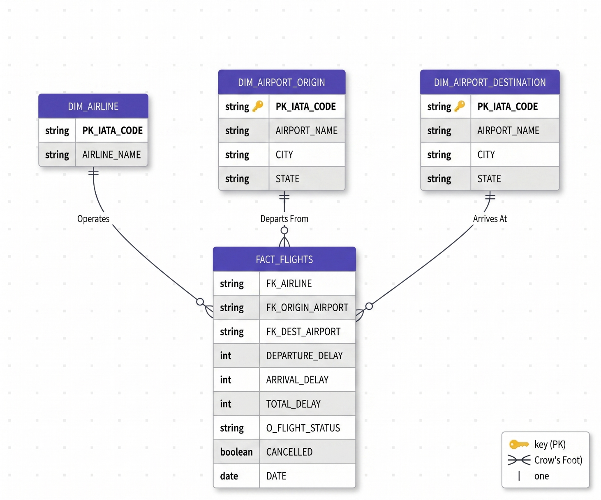

3. Dataset Description

This project utilizes a large-scale commercial aviation dataset (commonly sourced from Kaggle/FAA). The original raw data is distributed across three separate flat files (CSVs) which act as the foundational sources for the ETL pipelines.

1. flights.csv

Description: This is the massive core dataset (approximately 578 MB) containing millions of individual flight records. It serves as the raw, unstructured source for the central Fact table. It contains historical logs of scheduled flights, actual departure/arrival times, and delay metrics.

Key Columns:

YEAR, MONTH, DAY, DAY_OF_WEEK: Date and time parameters indicating exactly when the scheduled flight took place.

AIRLINE: The raw 2-letter identifier for the airline operating the flight.

ORIGIN_AIRPORT: The raw 3-letter IATA code indicating where the flight took off from.

DESTINATION_AIRPORT: The raw 3-letter IATA code indicating where the flight landed.

DEPARTURE_DELAY: Integer representing the number of minutes the flight was delayed upon takeoff. (Negative numbers indicate early departures).

ARRIVAL_DELAY: Integer representing the number of minutes the flight was delayed upon landing.

CANCELLED: A binary indicator (1 or 0) showing whether the flight was cancelled before takeoff.

2. airports.csv

Description: A master reference file (approximately 24 KB) containing geographical and naming data for commercial airports. This file requires cleansing and deduplication before being loaded as a formal Dimension table.

Key Columns:

IATA_CODE: The unique 3-letter code assigned to the airport (e.g., JFK, LAX, ORD).

AIRPORT: The official, full text name of the airport facility.

CITY: The city where the airport is geographically located.

STATE: The state or region where the airport is located.

3. airlines.csv

Description: A lightweight master reference file (approximately 1 KB) that maps the abbreviated airline codes used in the flights.csv file to their full corporate company names.

Key Columns:

IATA_CODE: The unique 2-letter identifier assigned to the airline (e.g., UA, DL, AA).

AIRLINE: The official, full text name of the commercial airline (e.g., United Air Lines Inc., Delta Air Lines, American Airlines).

4. Transformations With Scenarios

Scenario 1: Cleansing and Deduplicating Airport Reference Data (m_Load_Dim_Airports)

• Business Need: The raw airports.csv file contains inconsistencies and potential duplicates. To build a reliable Dimension table for the data warehouse, the data must be sanitized.
• Transformation Logic: An Expression transformation is used to strip out unwanted invisible spaces using LTRIM(RTRIM()) on the IATA codes. The clean data is then passed through a Sorter transformation with the 'Distinct' property enabled to permanently delete any duplicate airport records before loading them into the final Dim_Airport target.

Transformations :
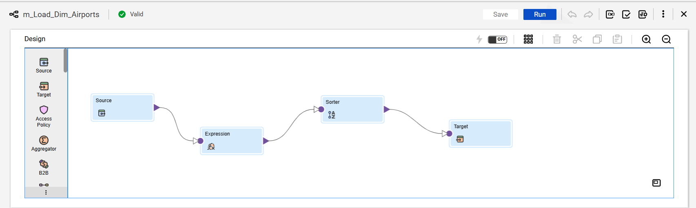

Scenario 2:Conditional Routing and Fact Table Generation (m_Load_Fact_Flights)

• Business Need: The business requires separated datasets for delayed flights versus on-time flights to feed different analytical dashboards. Furthermore, the total delay must be calculated dynamically.
• Transformation Logic: The massive flights.csv file is ingested. A Lookup transformation verifies the incoming airline codes against the clean Dim_Airline file to ensure data integrity. Next, an Expression transformation calculates the total delay (DEPARTURE_DELAY + ARRIVAL_DELAY) and tags the row. Finally, a Router transformation acts as a conditional switch, splitting the data stream: flights with >15 minutes of delay are routed to Fact_Delayed_Flights, while the rest are routed to Fact_OnTime_Flights.
Transformation :
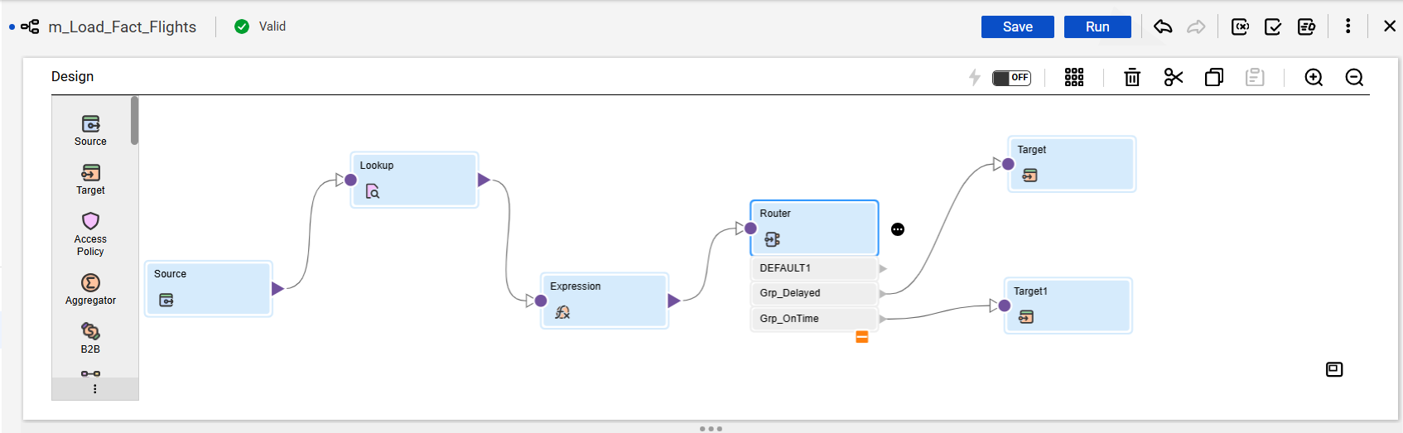

Scenario 3:High-Level Analytics and Aggregation (m_Agg_Airline_Delays)

• Business Need: Executives need a quick summary of which airlines are performing the worst, rather than looking at millions of individual flight records.
• Transformation Logic: Instead of passing raw rows, an Aggregator transformation is deployed. The data is grouped by the AIRLINE column, and the AVG() function is applied to the departure delays. This compresses thousands of rows into a clean, lightweight summary file showing the average delay per airline.
Transformation :
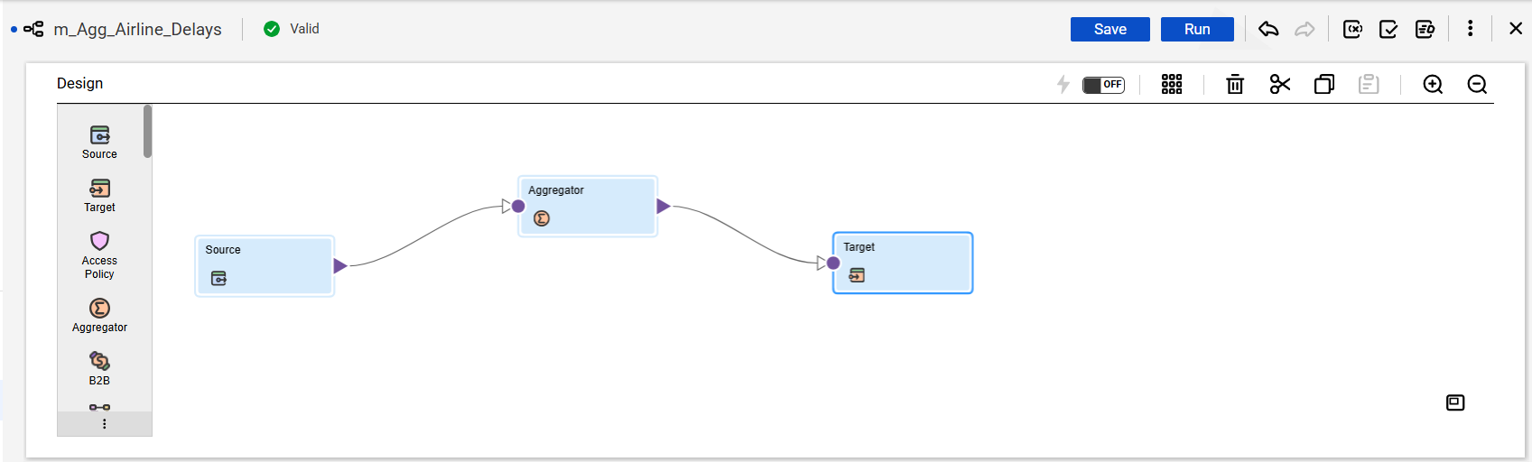

Scenario 4: Isolating and Ordering Extreme Performance Outliers (m_Rank_Worst_Delays)
• Business Need: Executive dashboards require immediate visibility into operational failures, such as the flights with the most severe departure delays. However, generating this report from millions of historical records requires data sanitization to ensure cancelled flights don't skew the results, and the final output must be strictly ordered for executive presentation.
• Transformation Logic: A multi-stage optimization pipeline is constructed. First, a Filter Transformation processes the raw data stream, actively dropping any records where CANCELLED = 1. This reduces the computational load. The clean data then passes into a Rank Transformation, which caches the data in system memory, evaluates the DEPARTURE_DELAY column, and outputs only the Top 50 highest values. Finally, a Sorter Transformation intercepts these 50 rows and orders them in strict Descending order based on delay severity. This highly optimized pipeline delivers a perfectly clean, ordered subset of critical outliers to the Target table without overwhelming the BI tools.
